4. (Slightly modified version of Ex 7-49 on p 297) For each of 18 preserved cores from oil-wet carbonate reservoirs, the amount of residual gas saturation after a solvent injection was measured at water flood-out. Observations, in percentage of pore volume, were

23.5 31.5 34.0 46.7 45.6 32.5 41.4 37.2 42.5 46.9 51.5 36.4 44.5 35.7 33.5 39.3 22.0 51.2

1. Construct a boxplot of this data, and comment on any interesting features.

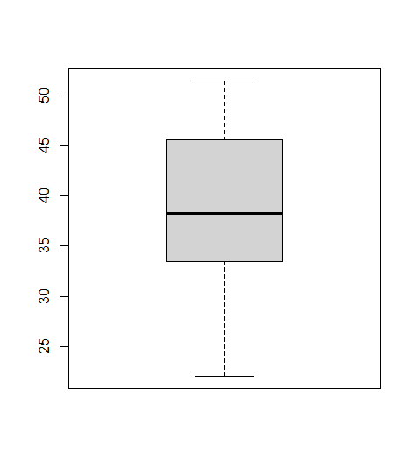

|  |  |  |  |  |  |  |
| --- | --- | --- | --- | --- | --- | --- |
| Min | 1Q | Median | Mean | 3Q | Max | IQR |
| 22.00 | 33.62 | 38.25 | 38.66 | 45.33 | 51.50 | 11.71 |

1. Is it plausible that the sample was selected from a normal population distribution?
2. Calculate a 98% CI for the true average amount of residual gas saturation.